Property Rental Management System with JWT Authentication

Developed a Property Rental Management System that enables secure user authentication and rental property management with Create, Read, Update, and Delete (CRUD) functionality using FastAPI and JWT.
Trainer Name-Amol Shinde Sir (Genosis Plus)
Team –
Tanaya Chaudhari -ADT23SOCB1204
Shreyas Deshmukh-ADT23SOCB1079
Abhayraj B.-ADT23SOCB0018
Kavya Kadwawat -ADT23SOCB0511
Salvin Sunny-ADT23SOCB0949

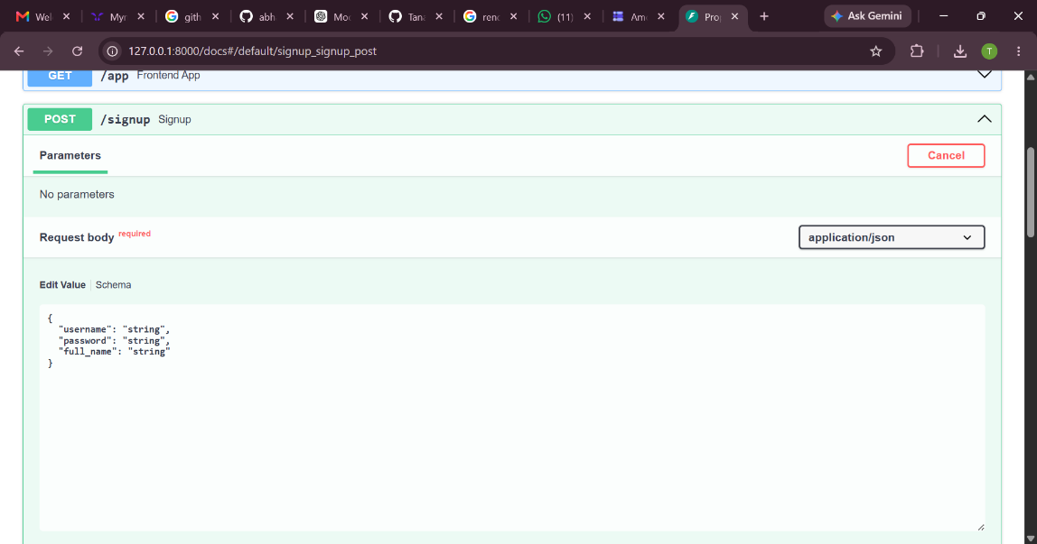

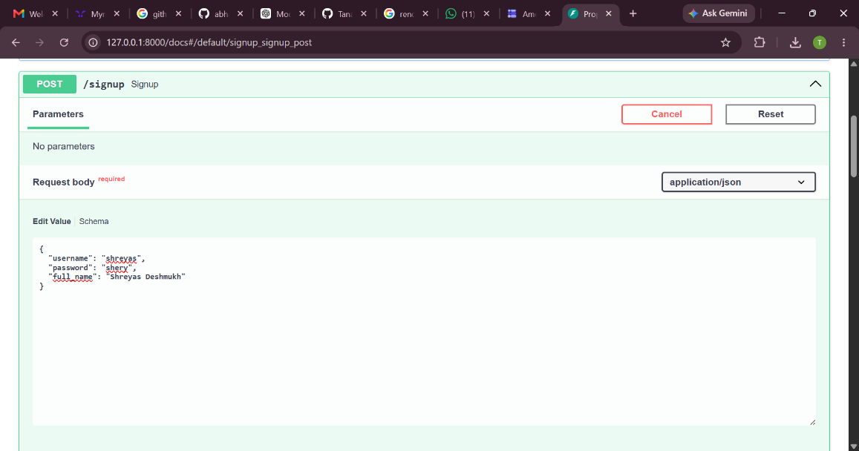

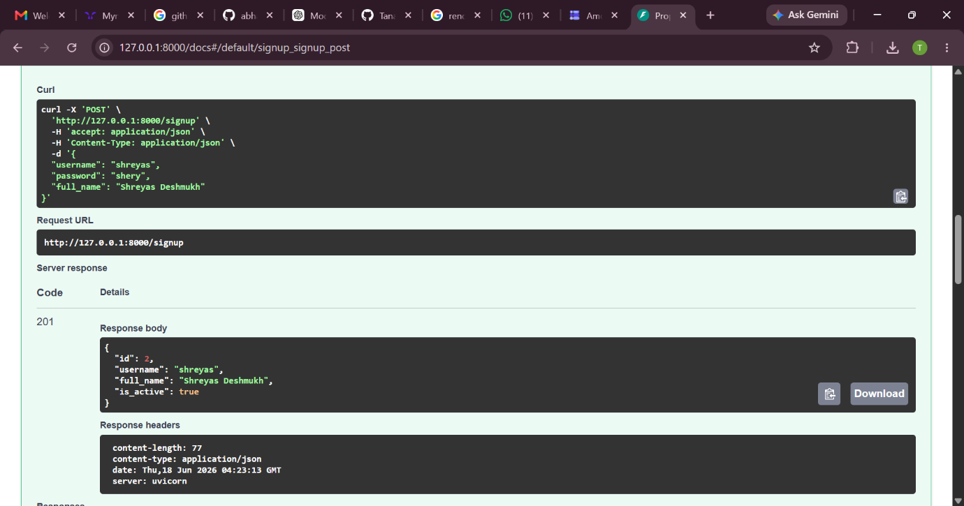

POST /signup was used to register a new user and securely store user credentials in the system.

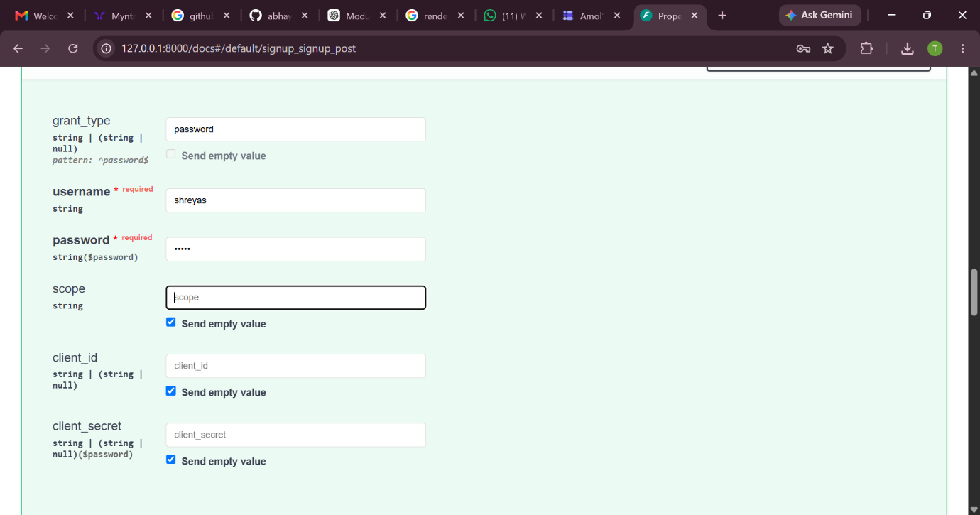

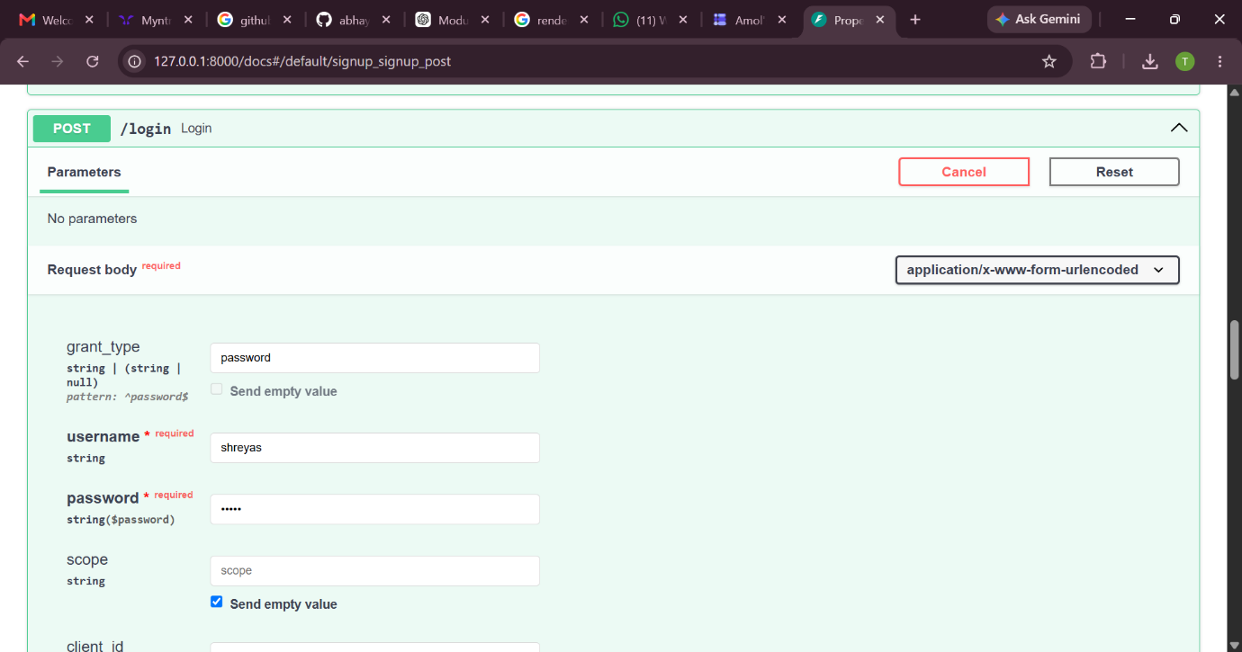

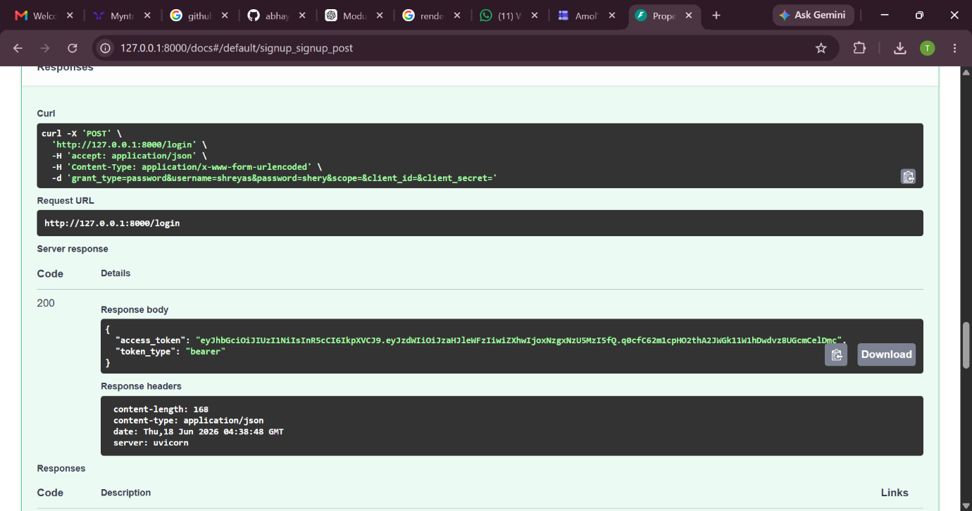

POST /login was used to verify user credentials and generate a JWT access token for authorization.

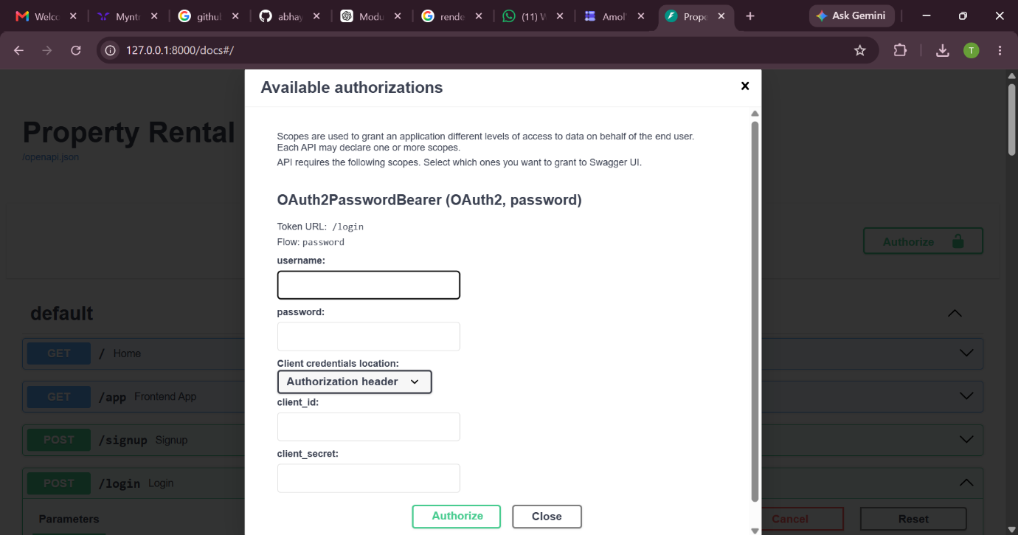

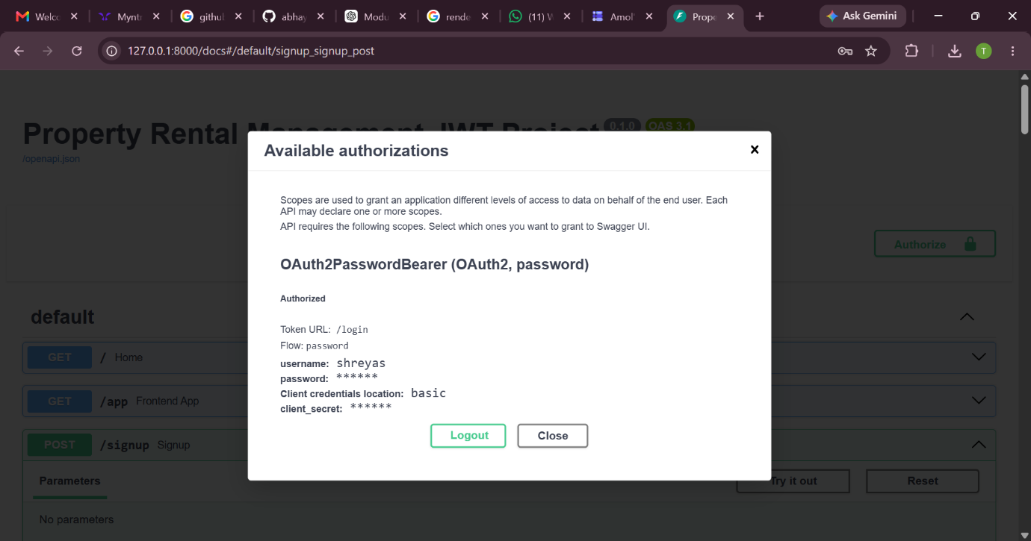

OAuth2 Password Bearer authentication was used to authorize the user and provide secure access to protected endpoints.

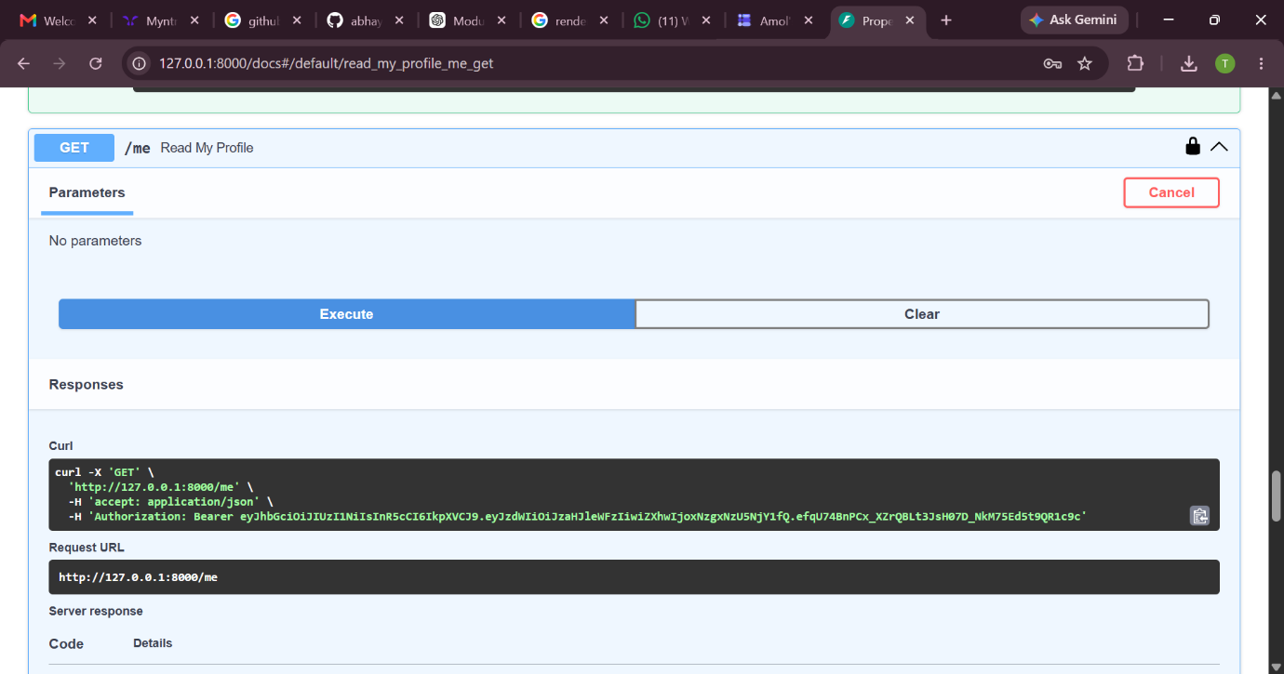

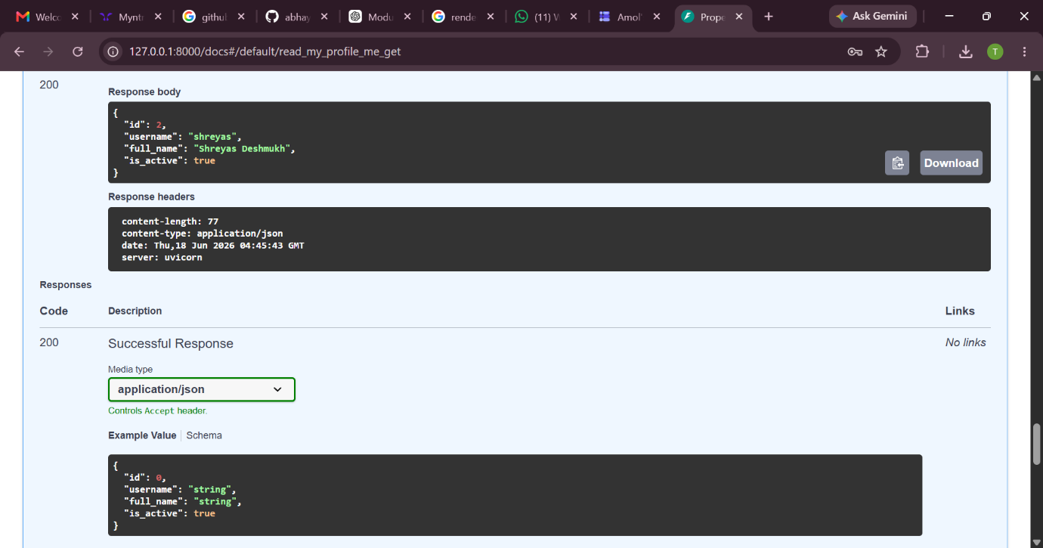

GET /me was used to retrieve the details of the currently logged-in user after successful JWT authorization.

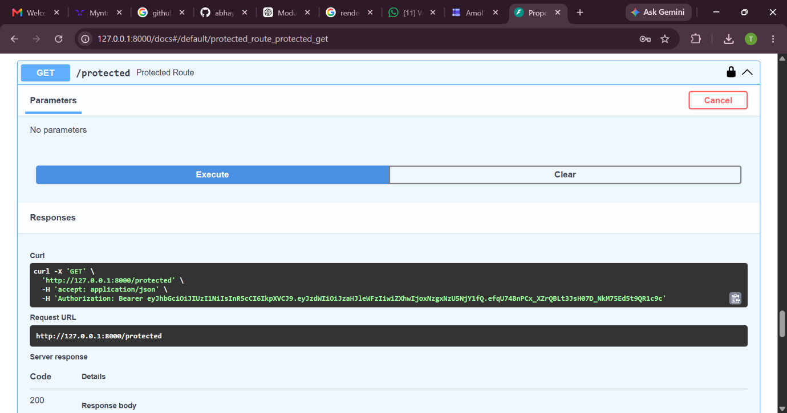

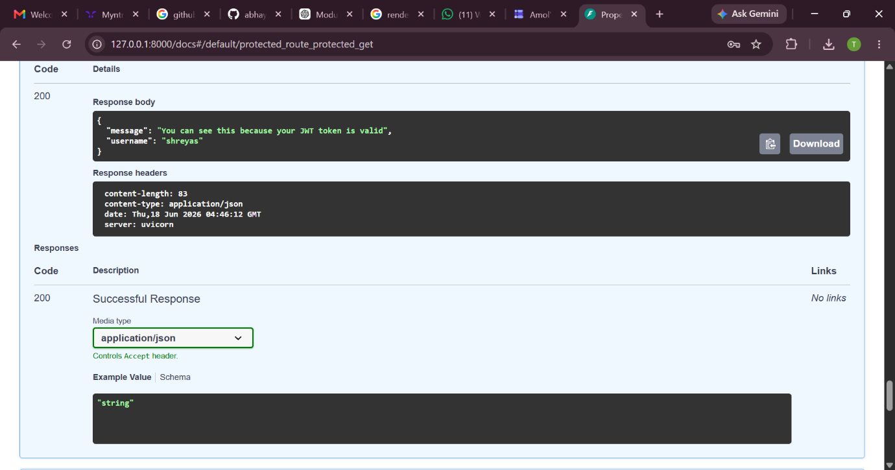

GET /protected was used to validate the JWT token and verify authorized access to protected resources.

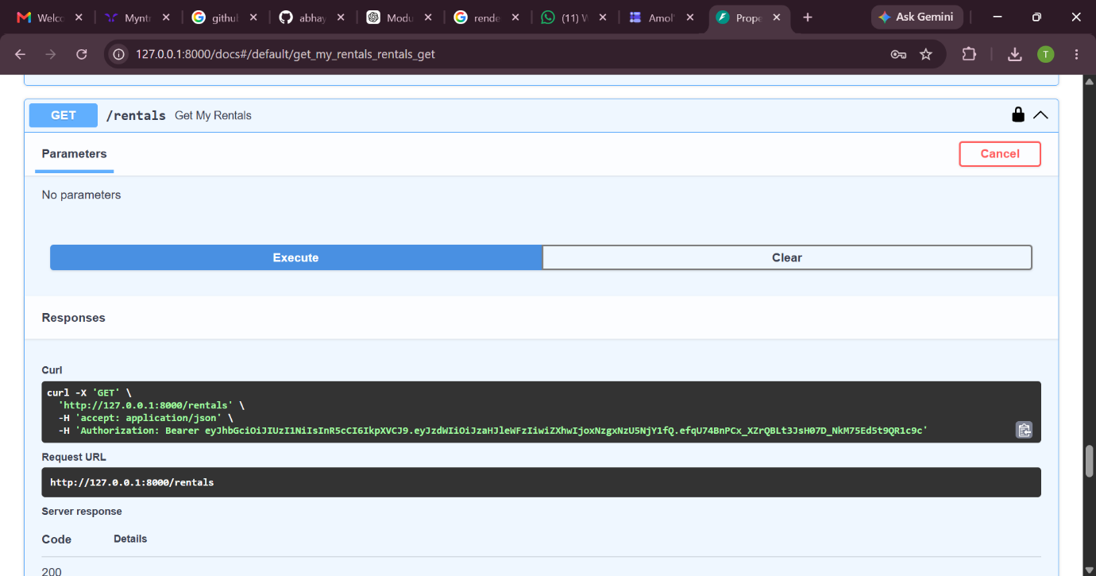

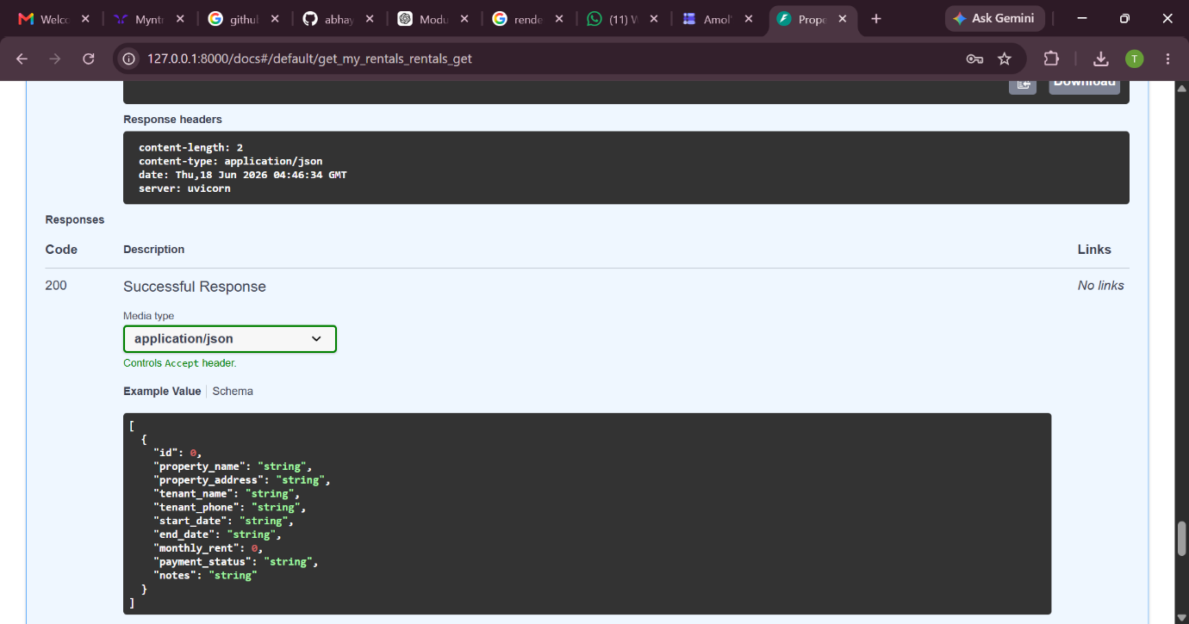

GET /rentals was used to retrieve all rental records belonging to the authenticated user.
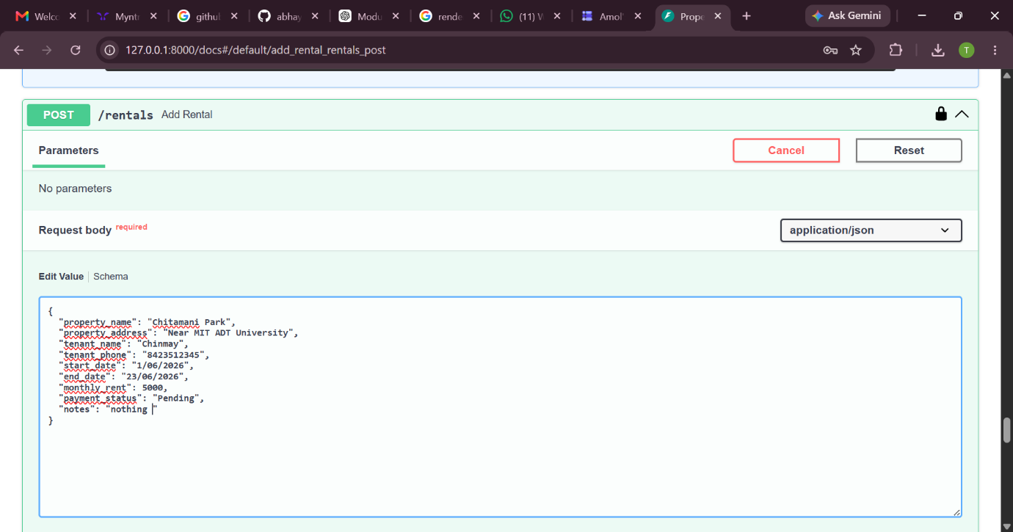

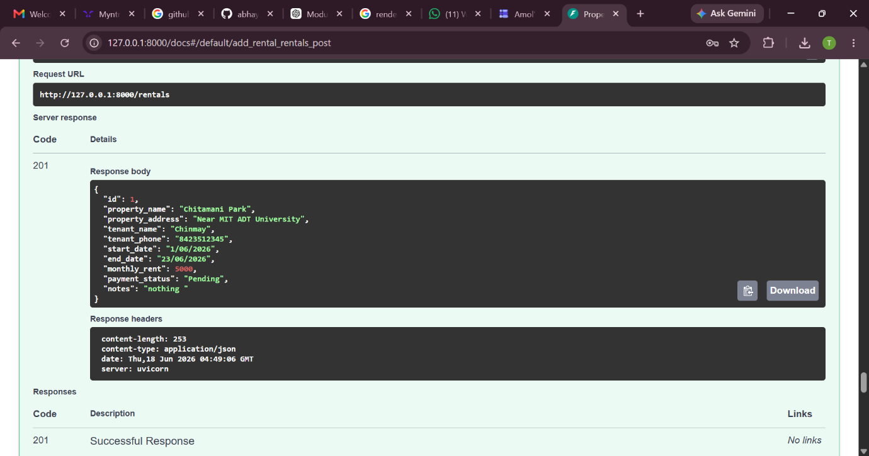

POST /rentals was used to create and store a new rental property record for the authenticated user.

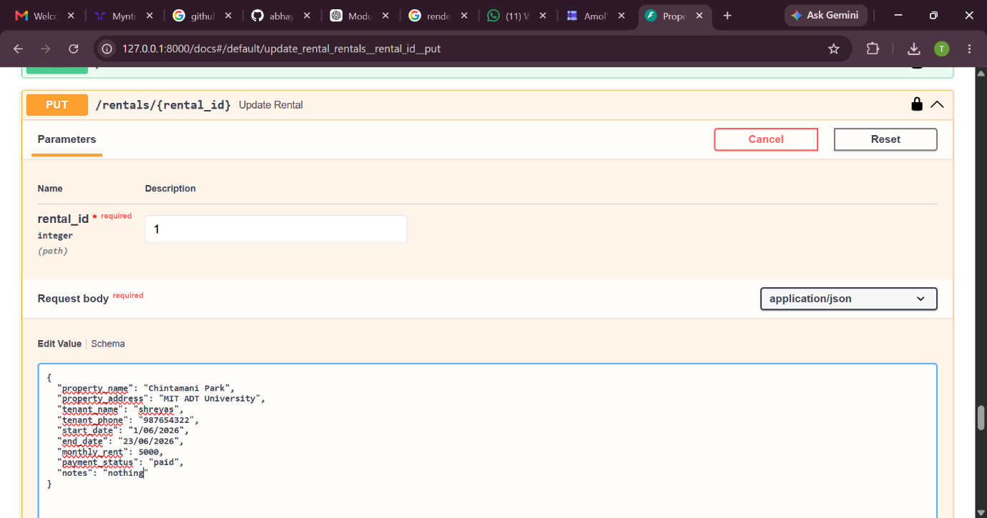

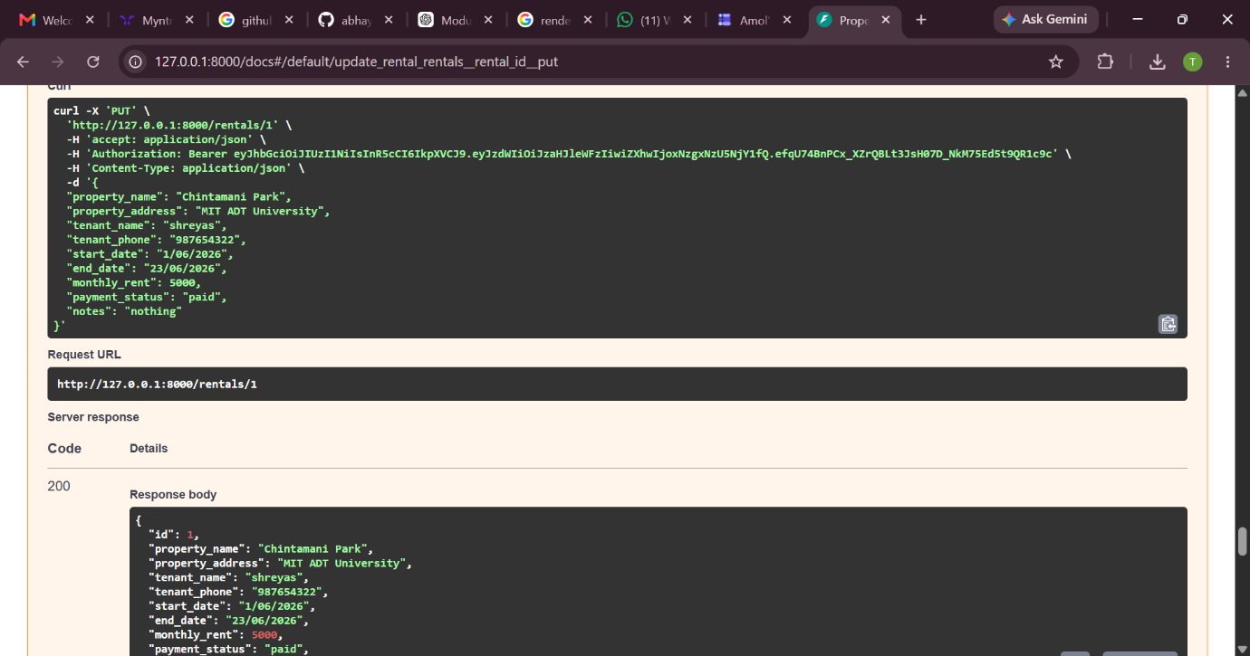

PUT /rentals/{rental_id} was used to modify an existing rental record and save the updated information in the database.

